LAUNCH INSTANCE

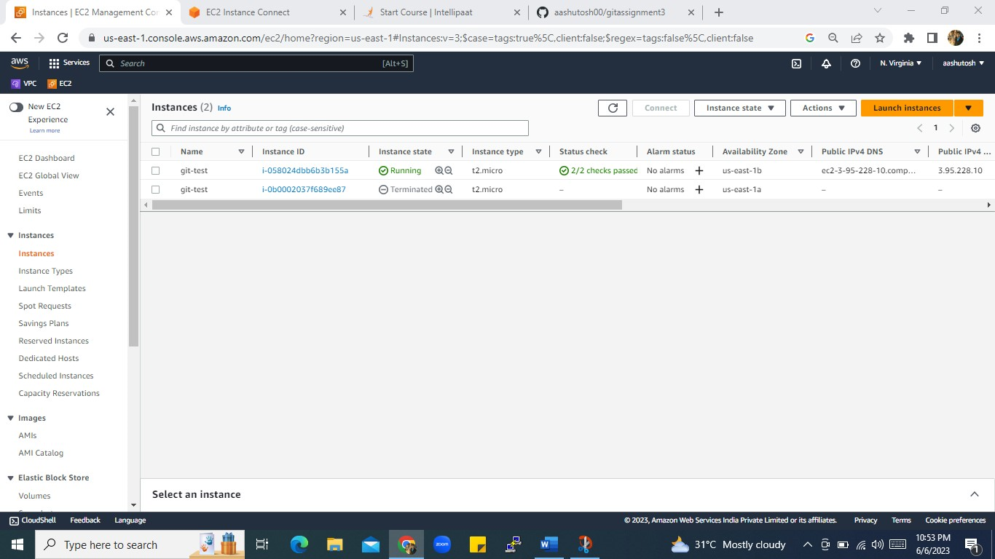

SCREEN SHOT 1

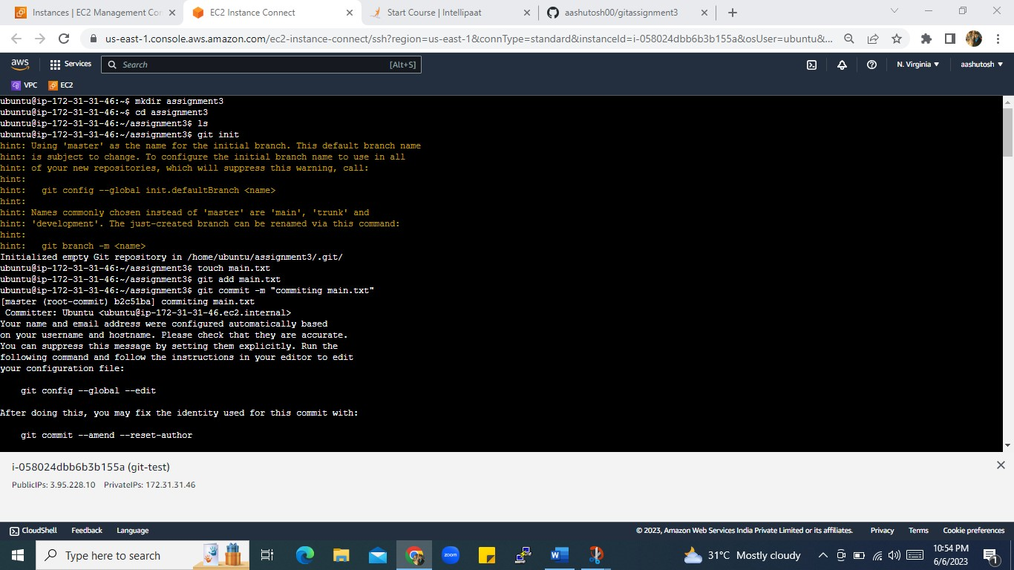

SCREEN SHOT2

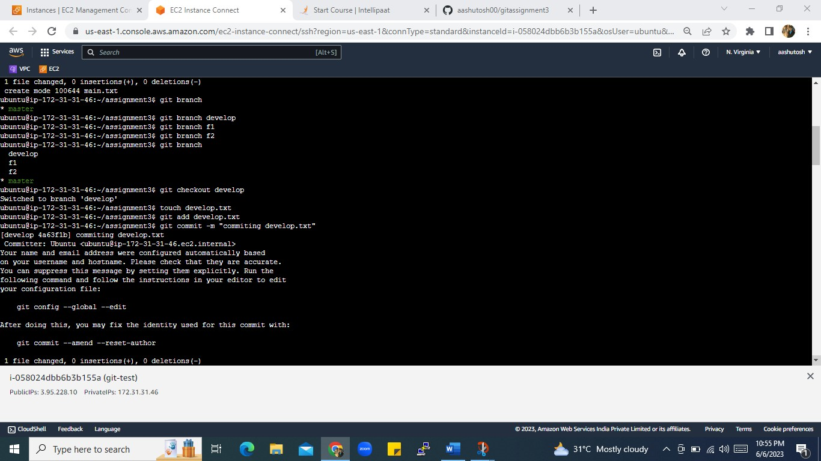

SCREEN SHOT3

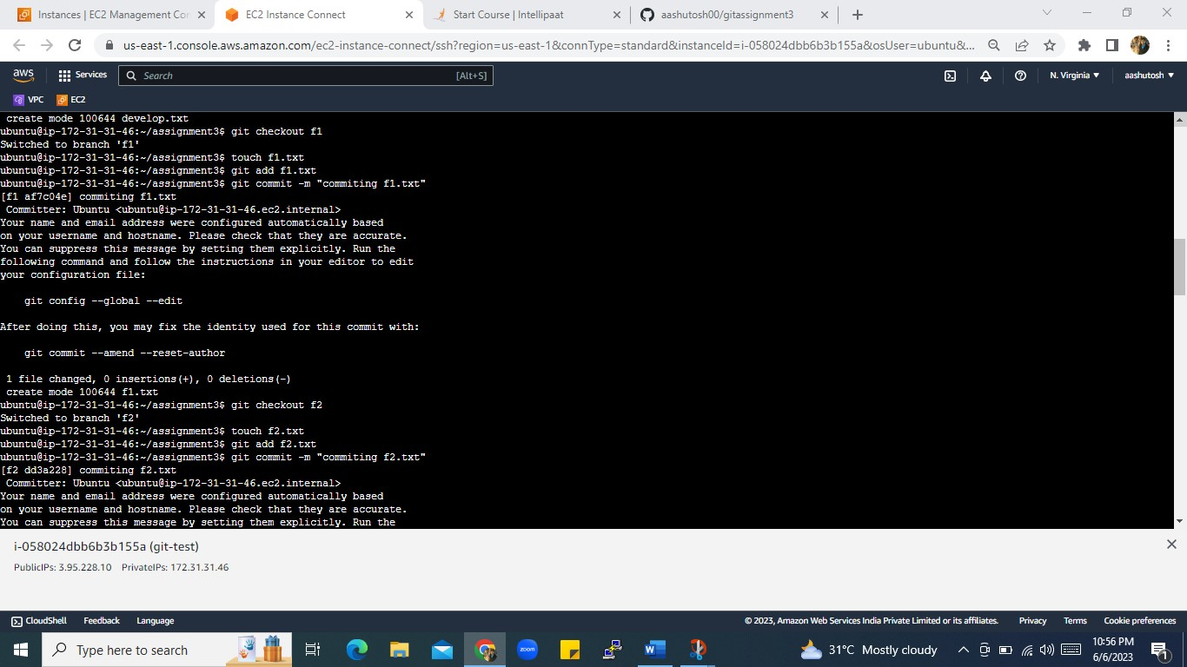

SCREEN SHOT4

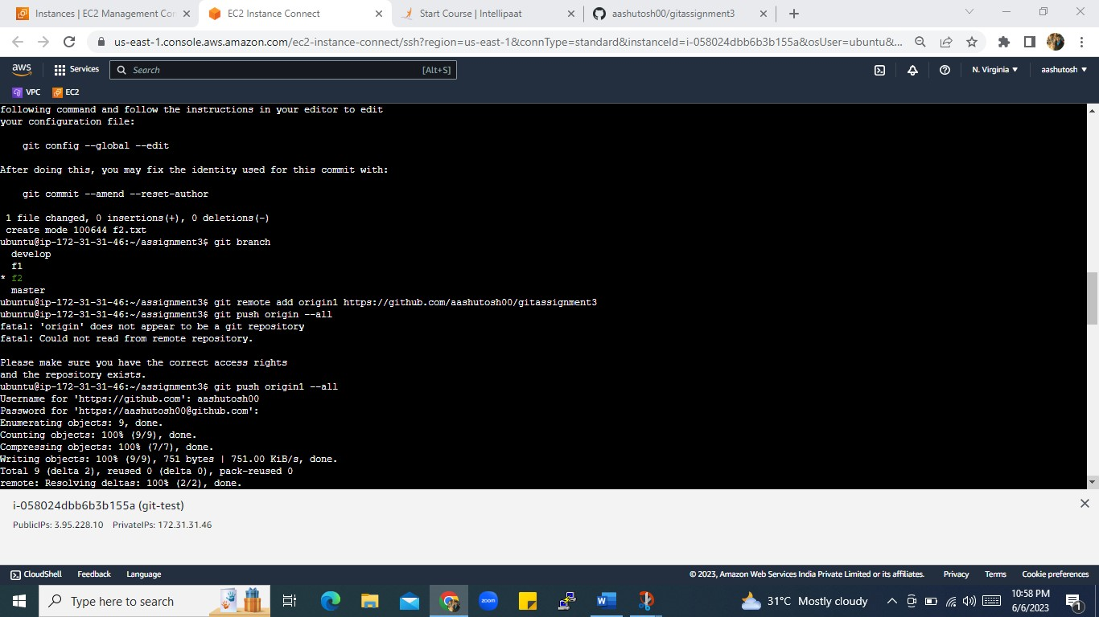

SCREEN SHOT 5

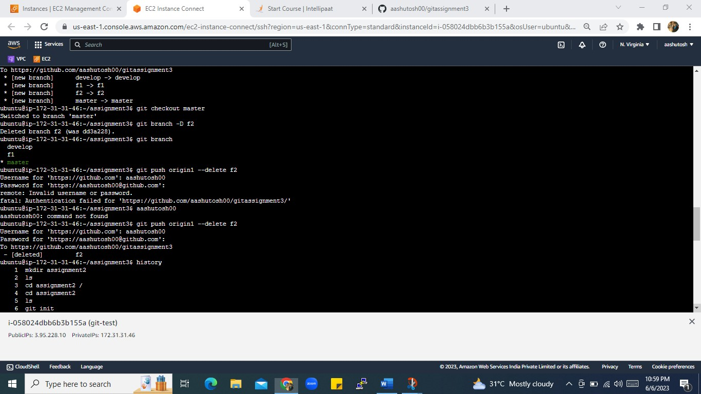

USED COMMAND HISTORY 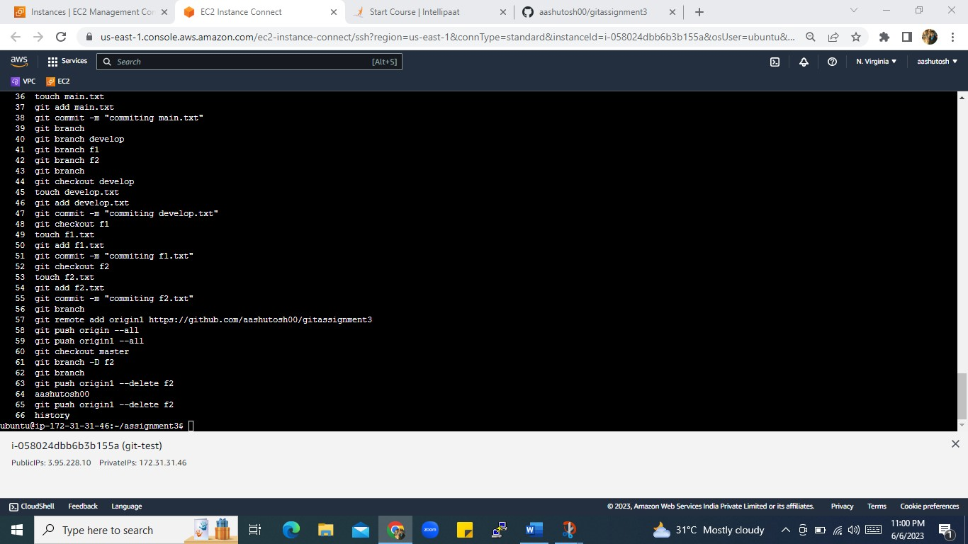

PUSH ALL BRANCH AT GITHUB

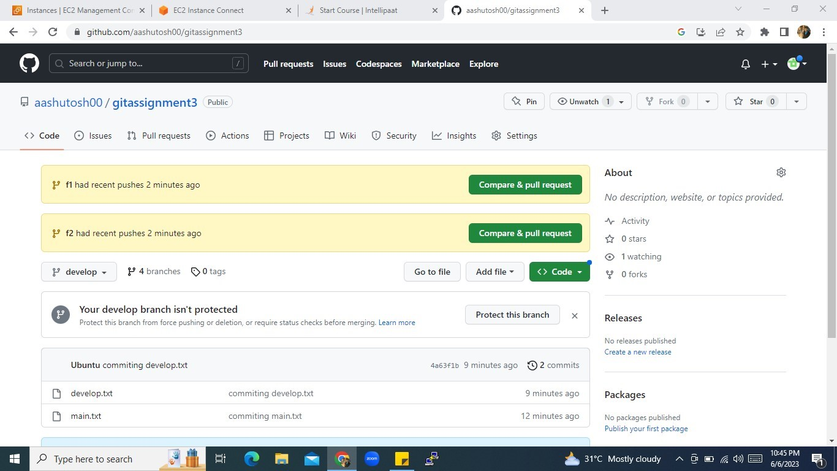

DELETE F2 FILE FROM GITHUB